Ref No: GU/ Disciplinary /2024/C-184/Consolidated Date: 1/12/2024

SUSPENSION ORDER
The undermentioned students of the university have been accused of fighting with each other in the GU campus

Sr. No. | Admission No. | Name of Student | Photo | Program | Year
1 | 24SCSE1040801 | Mr. Piyush Kumar | 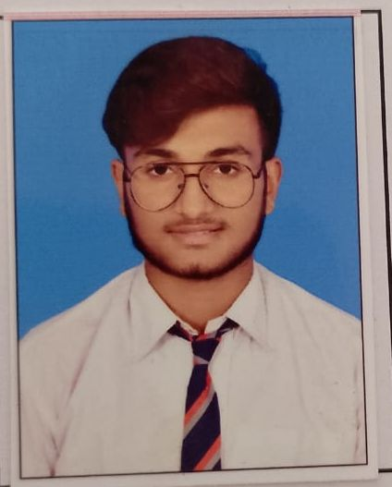 | BCA | I
2 | 23SCSE1010496 | Mr. Aaduitya Pratap | 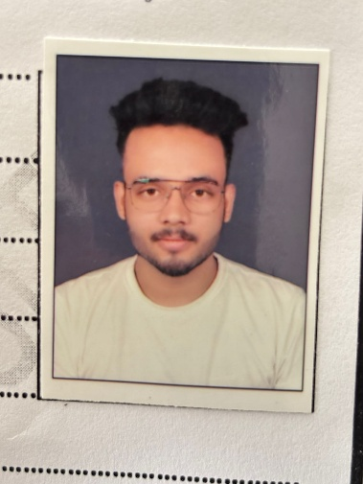 | B. Tech CSE | II
3 | 23GSOB1010137 | Mr. Asad Hafiz | 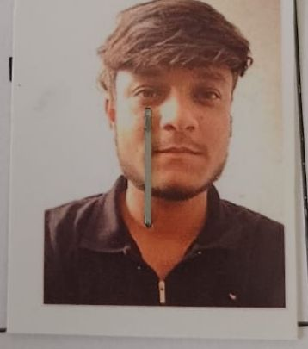 | BBA | II
4 | 22SCSE1040022 | Mr. Ajit Singh | 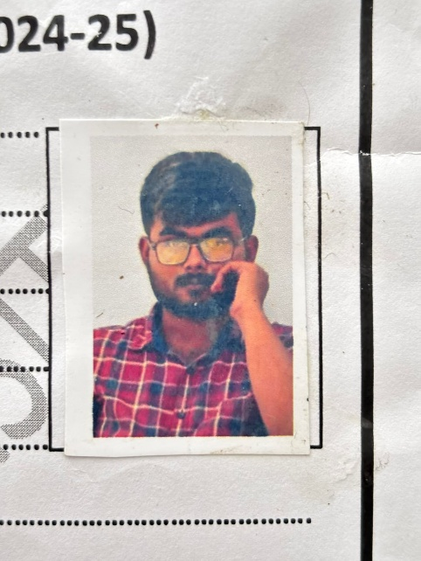 | BCA | III
5 | 24SBBS1170044 | Mr. Aryan Shukla |  | B Tech Biotech | I
6 | 22SAHS1050056 | Mr. Sourav Gurjar |  | BA Pol Sc | II
7 | 23SCSE1430172 | Mr. Vivek Kumar | 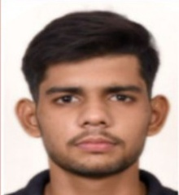 | BCA | II
8 | 23SCSE1040600 | Mr. Manas Gupta | 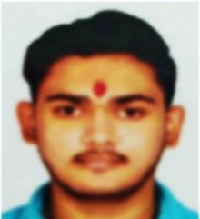 | BCA | II
9 | 23SOAG1010060 | Mr. Sarthak Srivastava |  | B. Sc. Agri | II
10 | 24GSOB2011385 | Mr. Abhishek Tawar |  | MBA | I

The Students Disciplinary Committee has decided to SUSPEND them with immediate effect till further orders. They are required to submit a written explanation to the undersigned by 2/12/2024 as to why further disciplinary action including rustication should not be initiated against him. They are also required to be present along with their parents at the Students Disciplinary Committee meeting on 10/12/2024 (noon).

They are not allowed to attend any class / appear in any exam/ participate in the placement activity with immediate effect till further orders. They are not allowed to stay in the hostel till further orders.

Dr. P. K. S. Nain
D.S.W & Chief Proctor
CC:
- Secretary to Chancellor for kind information, please.
- Secretary to CEO for kind information, please.
- Secretary to VC for kind information, please.
- Secretary to PVCs for kind information, please.
- Registrar
- Deans
- Controller of Examination
- Concerned Faculty Members
- Concerned Students & Parents through school Dean
- ERP
- LMS
- Notice Board
- Finance Office
- Hostel Warden

